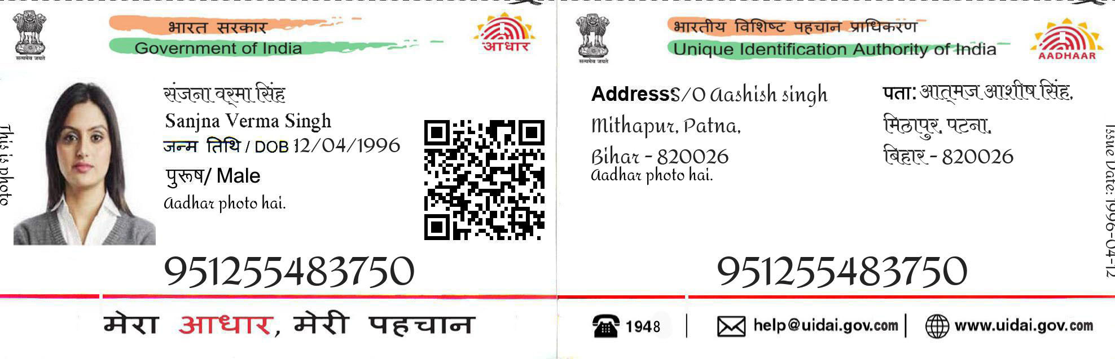

699651787

552964642860

Address;vinay kumar singh Chauhan

Behta nathai singh post korari kalan [unnao]

Narayani singh Chauhan

Dob 5/7/2004

female